



Coding Agents in Noteable

Staff and Student Guidance

Academic Year 2026–27

Noteable now give students access to Codex, Claude and OpenCode coding agents.
These tools are available from the command line in all Noteable notebook environments and can support AI-assisted coding, debugging, explanation, notebook development and exploratory programming.
Noteable provides a safe and managed space for students and staff to experiment with AI-assisted and agentic programming. Behind the scenes, Noteable sessions run in containerised notebook environments, providing a strongly sandboxed workspace for code development and testing.
Note that while our Jupyter and RStudio environments are updated outside of teaching time, coding agents will be updated more frequently.
We recognise that requirements around AI use vary by course, cohort and assessment context. Noteable therefore provides flexibility for courses that wish to make use of these features.
For lecturers that do not wish to make coding agents available for their course/s, these can be disabled at institutional or course level.
Please test that the relevant AI tools for your course are available, whether Terminal-based access to Codex works as intended, and confirm that the available options support your intended teaching or workflow use cases.

What is a coding agent?
A coding agent is an AI-powered tool designed to help with software development tasks.
A coding agent is different from a general chatbot or standard large language model interface and it can often work more directly with files, code and the command line.
A coding agent may be able to:
- read files in a workspace;
- suggest and make code changes;
- edit or create files;
- explain code
- help debug errors;
- generate tests;
- help with notebooks and scripts;
- support multi-step programming tasks.
A general-purpose LLM usually responds to prompts in a chat interface. A coding agent can take actions in the user’s workspace.

Coding agents available in Noteable
The Noteable Summer 2026 update includes access to:
- Codex
- Claude
- OpenCode
These are available from the terminal/command line in Noteable environments.
Noteable provides access to the coding-agent tools. Users will need to authenticate with, or provide an API key for, the relevant AI provider. Access requirements, available models, usage limits and any associated costs vary between coding agents and providers.
Any charges incurred through an AI provider are payable directly to that provider and are not included in a Noteable subscription.
Before using a coding agent in teaching, staff should confirm the required account, authentication and API arrangements, and test the intended workflow in the relevant Noteable environment.
The video below goes over the set up process and getting started with coding agents using an example API key from EDINA’s ELM ® service.*
*See bottom of document for information about ELM.


How to disable coding agents for a course or institution
Coding agents can be disabled at course or institutional level where they are not appropriate for teaching or assessment.
If you are a course organiser or institutional administrator, please request this through your usual Noteable support route or the Noteable contact form. Include:
- your institution and contact details;
- the course title and course code, or confirmation that the request is institution-wide;
The Noteable team will review and confirm implementation of the change. Before teaching or assessment, please check that the tools are no longer available in the relevant course environments.
Disabling coding agents in Noteable does not prevent students from accessing external AI services. Local course and assessment guidance should therefore clearly communicate any restrictions on AI use.

How to access coding agents in JupyterLab notebook servers:
- Launch a Terminal
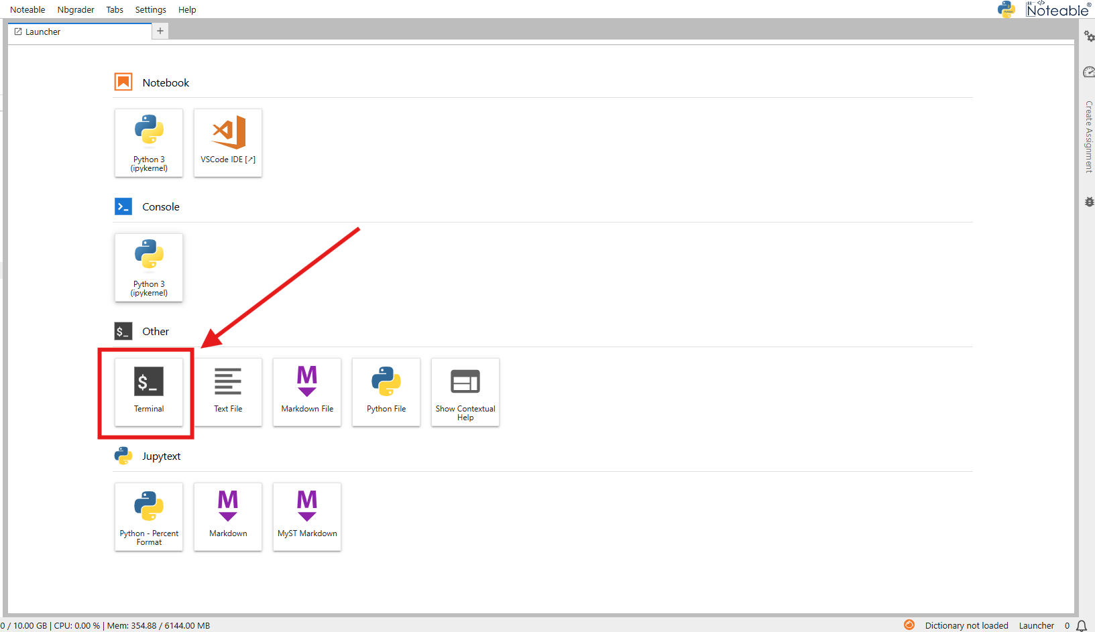

2. You can access coding agents directly through the Terminal, get started using <codingagent> --help 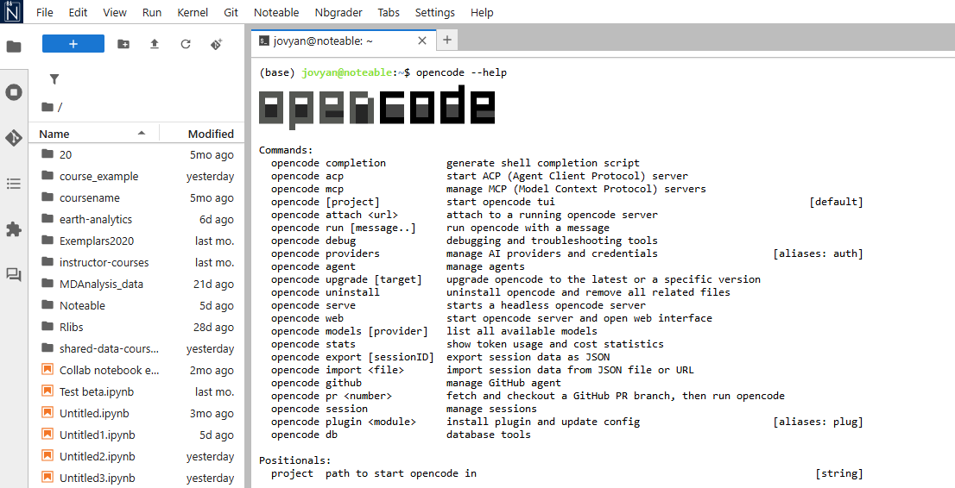opencode in the Terminal in Noteable JupyterLab environments
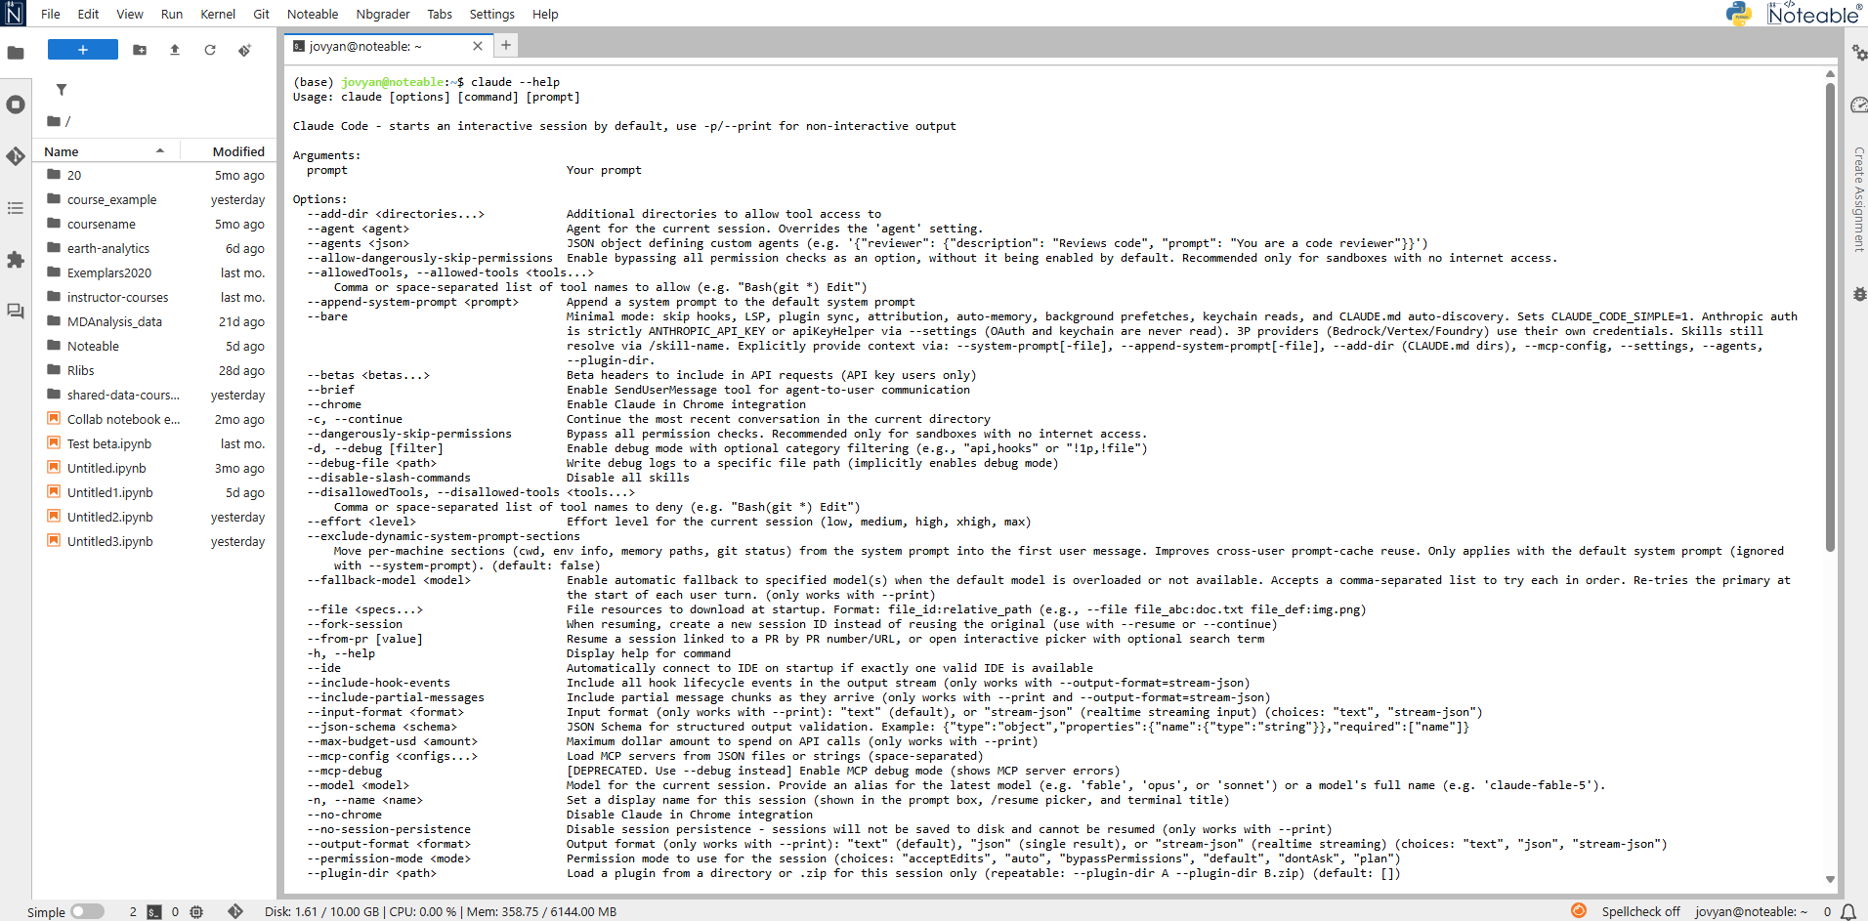Claude –help in the Terminal in JupyterLab environments
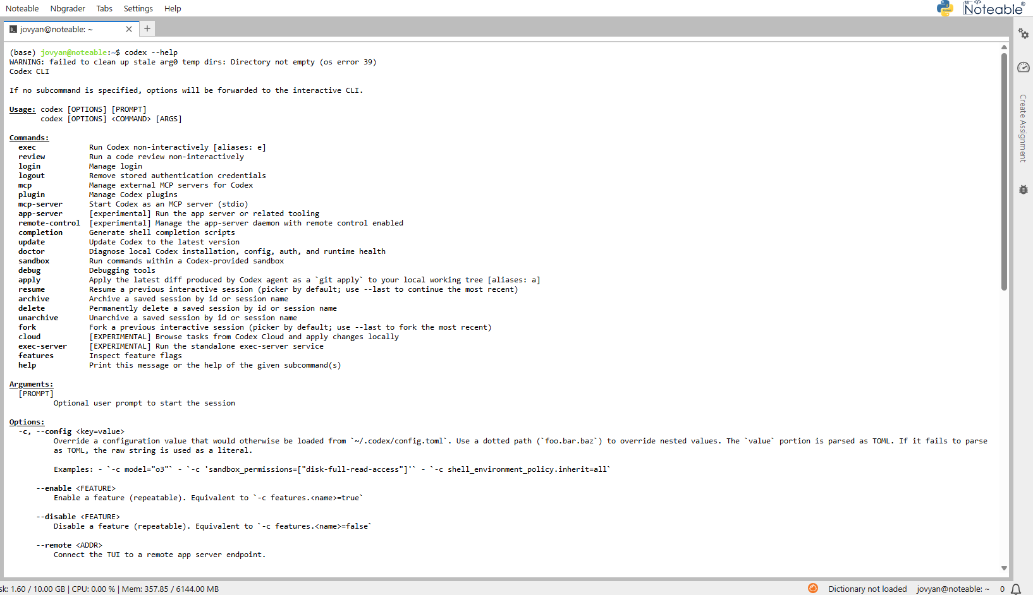Codex in the Terminal in Noteable JupyterLab environments
You can then write prompts and run relevant commands, for example:
codex starts the codex interactive session, while
codex –-help displays available commands and usage options.
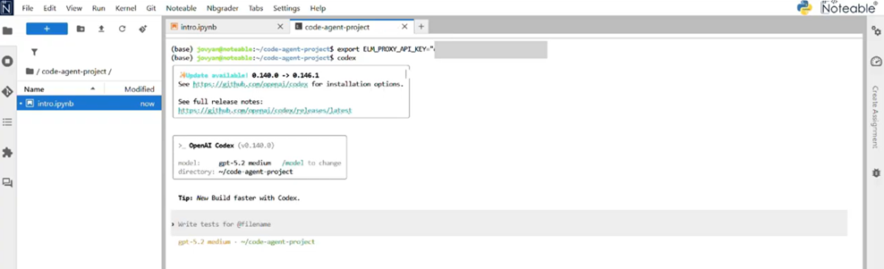

In RStudio:
- Launch your Noteable RStudio session.
- Open the Terminal pane (found in the upper-left quadrant; if not visible, go to Tools > Global Options > Terminal or click the "Terminal" tab).
- Run the agent commands directly (e.g., opencode --help, claude --help, or codex --help).
- Note: These agents operate at the system level within the container, allowing them to assist with R script development, package management, and file operations directly from the RStudio terminal.
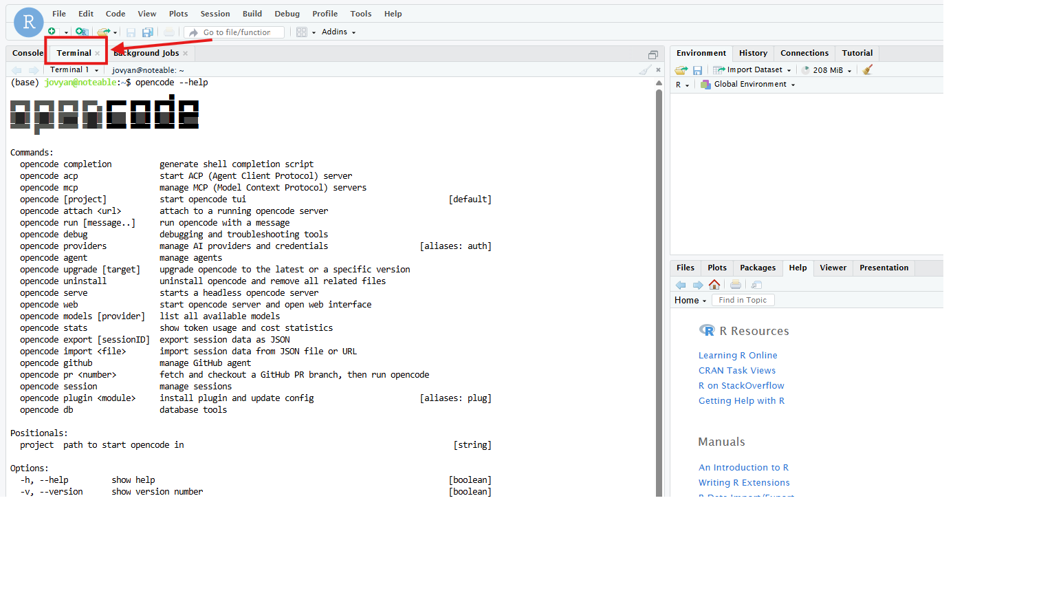
Coding agents may be updated more frequently than the main notebook environments. Notebook environments are usually updated outside teaching time, whereas coding agents may receive more frequent updates as provider tools and integrations change.

Why Noteable is a suitable place to use coding agents
Noteable is an excellent safe space for using coding agents because it provides a controlled teaching and learning environment.
Key features include:
- containerised notebook sessions;
- sandboxed user environments;
- consistent course environments;
- support for notebook-based teaching;
- options to enable or disable tools at institutional or course level.
This allows students to experiment with AI and agentic programming in a safer environment than working directly on a personal machine or unmanaged cloud system.

Testing checklist for staff
Before using coding agents in teaching, staff should test that:
- the required coding agents are available in the selected Noteable environment;
- terminal-based access works as intended;
- authentication works as expected;
- Codex, Claude and/or OpenCode support the intended workflow;
- students can access the relevant tools;
- the course position on AI use is clearly communicated;
- any required logging, declaration or acknowledgement process is in place.

ELM as an additional AI service
ELM ® is EDINA’s generative AI service: https://elm.edina.ac.uk/
For institutions interested in adding ELM ® to their wider digital learning provision, it can support access to approved AI models and compatible coding-agent workflows through ELM ® API keys.
To discuss ELM® for your institution, please contact EDINA.

Support and issue reporting
When reporting coding agent issues, please include:
- your university username;
- Course area and notebook environment used;
- the coding agent used and the command or workflow attempted;
- screenshots or error messages.
Please report issues via the Noteable contact form: https://noteable.edina.ac.uk/contact-us/

